1. Install java in the system. Verify using java -version in the cmd prompt. (Jenkins expects java 11 version)
2. Download Jenkins.war file

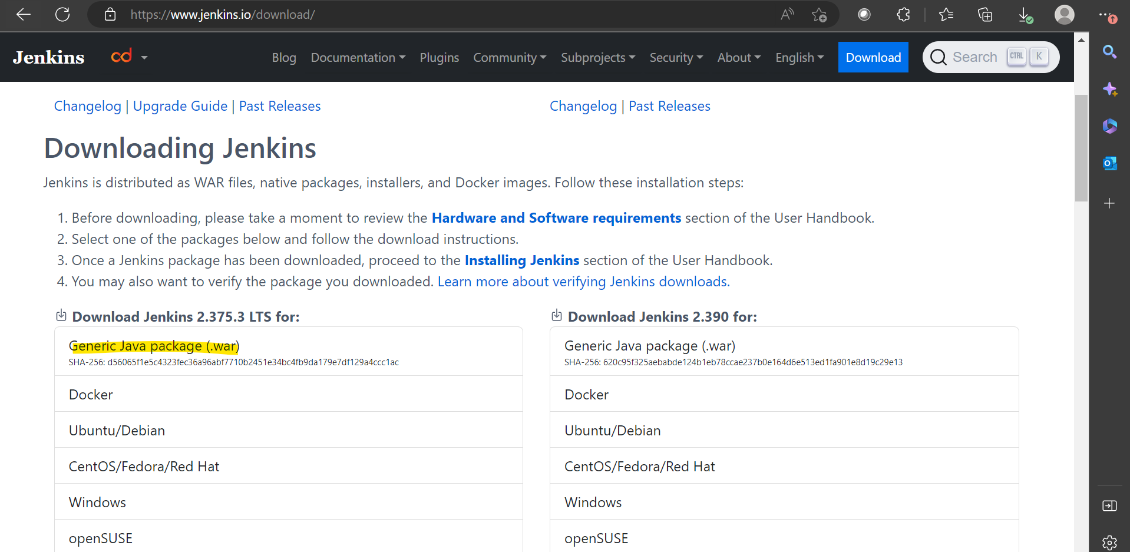

1. Go to the folder where this war file is placed and run java -jar Jenkins.war

This will start the Jenkins on the default port 8080

1. This is the initial password that is generated. Once you see the confirmation that Jenkins is fully up and running, visit localhost:8080 and paste the password

1. Click on Install suggested plugins and proceed.
2. Now create the admin user and password

Username : spraveen879

Pw : tapamth

url : <http://localhost:8080/>

1. Go to Manage Jenkins – Configure System. You will see the home directory of jenkins

1. Go to Manage Jenkins and Plugin manager to manage the plugins

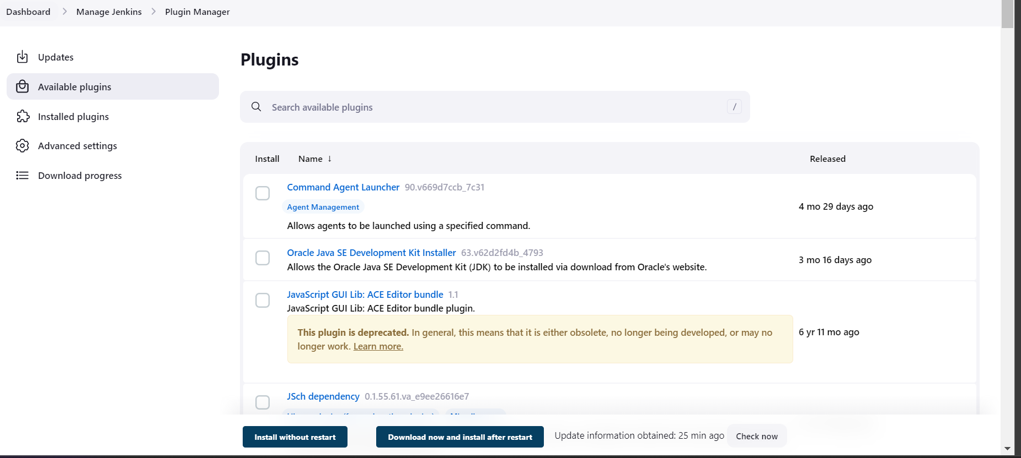

1. Change the home directory in Jenkins – Sometimes this is needed if there’s no enough storage space in the system or project requirements.
   1. Create a folder in the required location.
   2. Copy the contents from home directory to this location.
   3. Go to environment variables and specify this path in JENKINS_HOME variable.  
      Graphical user interface, application

      Description automatically generated
   4. Restart Jenkins using cmd prompt.
   5. The home directory would be updated. THIS WOULD BE THE DEFAULT DIRECTORY INSTEAD OF .jenkins in C:Users
2. **Integrate Git with Jenkins**

**Pre requisite 1** : Go to plugin manager and check if git is installed.

**Pre requisite 2** : Go to Manage Jenkins -> Manage credentials ->System -> Global credentials(unrestricted) and add credentials

Now add the username and password for git. Copy the username from github.com

Now, Create a new job by clicking New Item -> Freestyle project from the home page. Now the configuration for the job starts as below.

Go to source code management and enter the details as below. WE can select which branch has to be run. Here, we are selecting master. Click on apply and save

Click on Build now to see if the repository is linked with Jenkins.

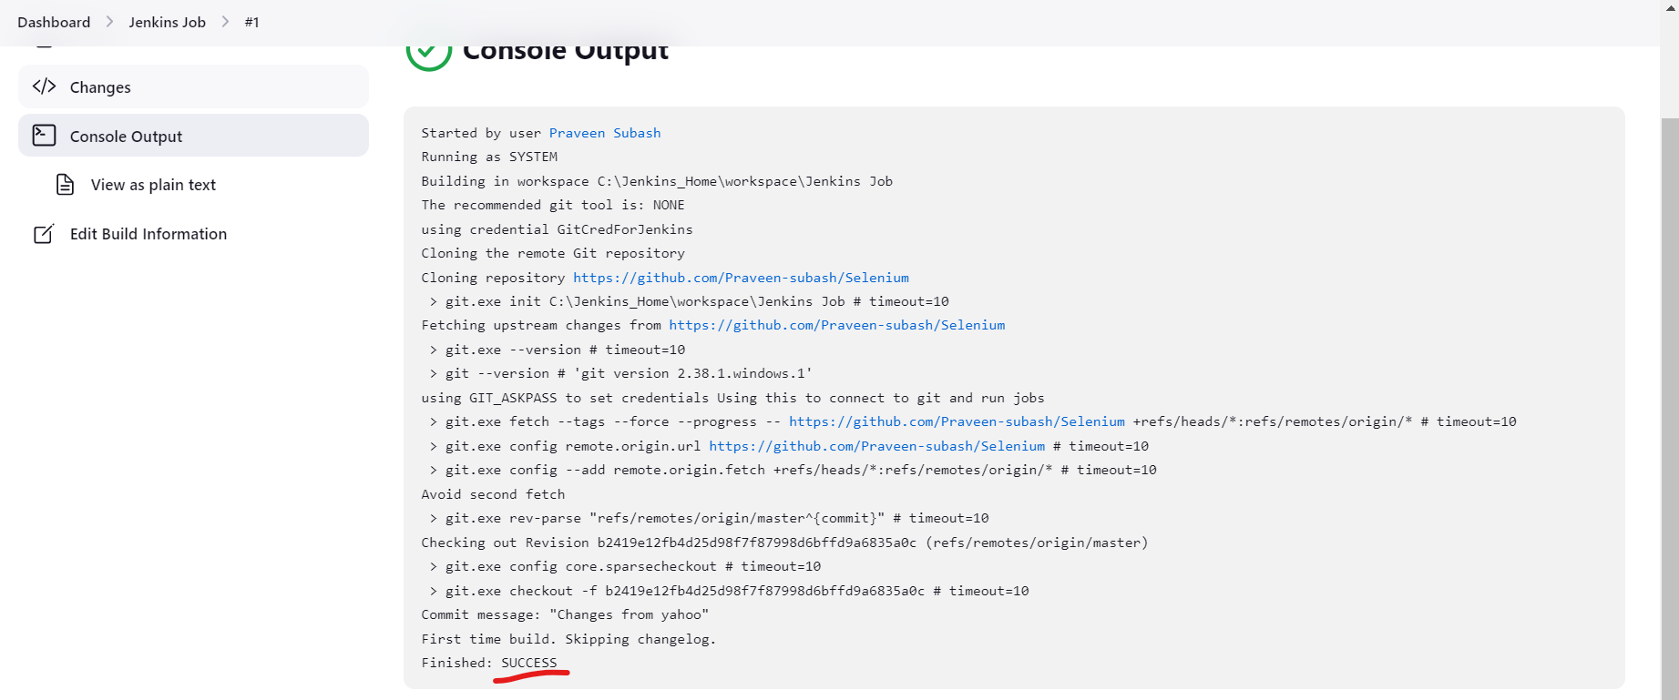

NOTE : IF YOU DON’T WANT TO CONNECT GIT IN DEFAULT DIRECTORY AS SET, USE THE BELOW OPTION TO GIVE CUSTOM WORKSPACE INSTEAD OF CONFIGURING DEFAULT DIRECTORY

1. **How to use command line in Jenkins CLI**

Go to Manage Jenkins -> Configure Global Security

Apply and save

Go to cli page of Jenkins - [***http://localhost:8080/cli/***](http://localhost:8080/cli/)and download the cli jar

Open the command line location of the folder and paste the command shown above

If you are seeing such authentication issues, run the below command

***java -jar jenkins-cli.jar -s*** [***http://localhost:8080***](http://localhost:8080) ***-auth username:password***

java -jar jenkins-cli.jar -s <http://localhost:8080> -auth spraveen879:tapamth

Now to get the list of commands, open this link

Now run the below command

***java -jar jenkins-cli.jar -s http://localhost:8080/ -auth username:password build* <jobname>**

java -jar jenkins-cli.jar -s http://localhost:8080/ -auth spraveen879:tapamth build "Jenkins Job"



1. **How to create users and assign roles**

Go to Manage Jenkins – Manage users – Create user and add users

To give role based access to users, go to Manage Jenkins -> Plugins and search for [Role-based Authorization Strategy](https://plugins.jenkins.io/role-strategy)

Once it is installed, go to Manage Jenkins -> Configure Global security ->Configure Global Security.

Under authentication select Role Based strategy. This will be visible only after plugin is installed.

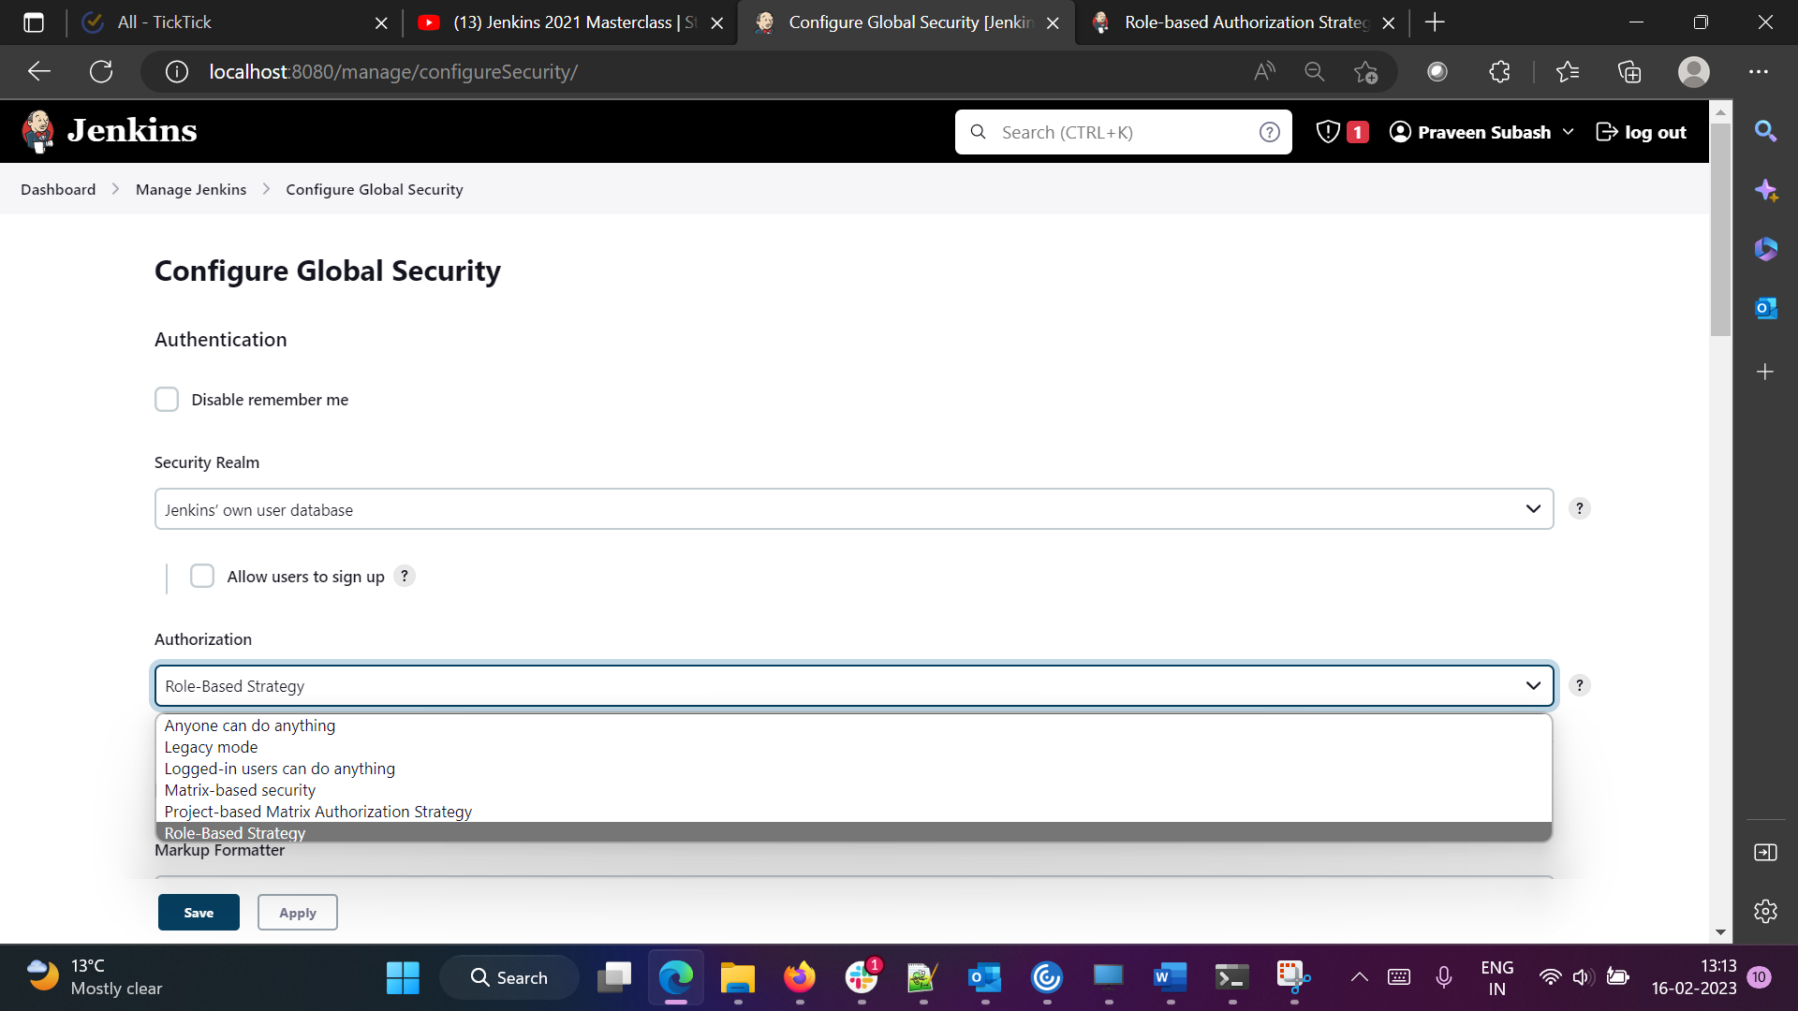

Now go to Manage Jenkins -> Manage and assign roles ->Manage roles

Create a role called employee and give the below access

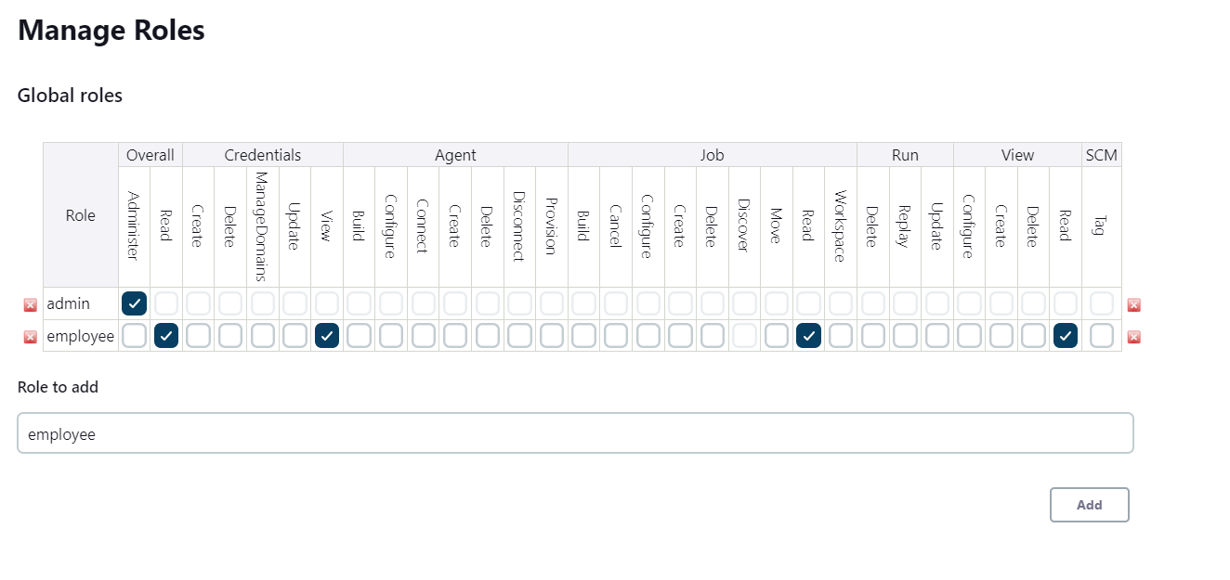

Under Item roles, create Developer and Tester roles. They can run jobs with prefix Test.* and Developer.*

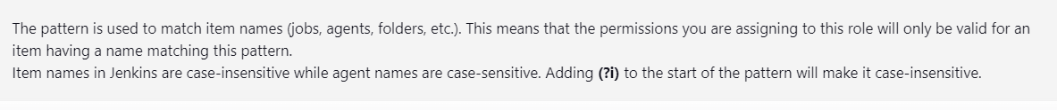

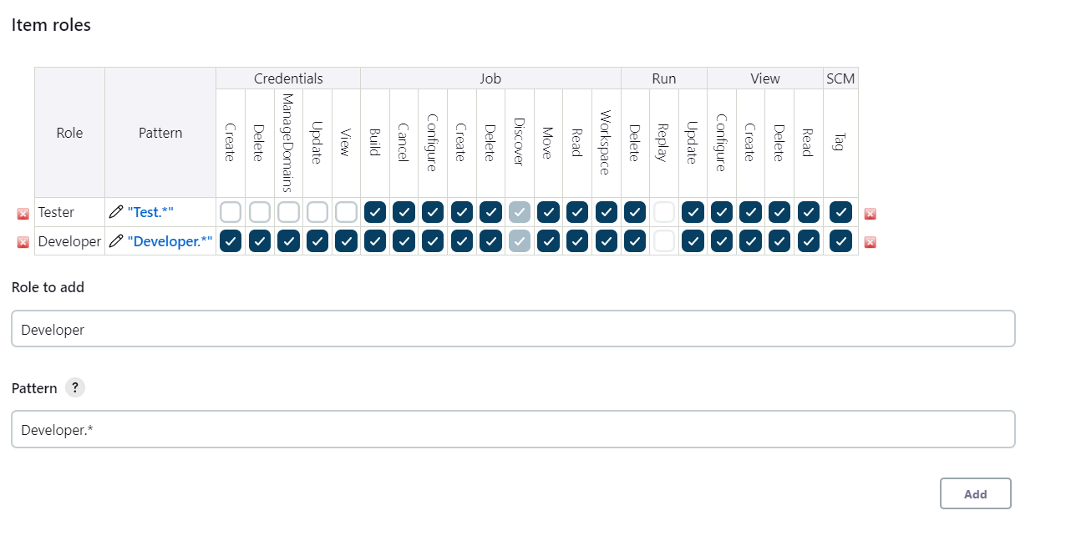

Now go to Assign roles and add the created user and roles

Here, I have added the users created and assigned them employee roles

We can add item based roles and give the permissions

Now create two new jobs DevJob and TestingJob

Now login with spraveen_test1 which has roles set for Test.* He has all access to test job

But he does not have access to dev job due to the permissions set. Similar for spraveen_test2, dev job will be given access where testing job does not have.

1. **Chain Jobs**

We are now going to chain two jobs. For now instead of running anything on git, I am just going to print the content.

***So, go to Testing and Dev Job and add this step***

Job – Configure – Build Environment – Add build step – Execute windows batch command

Replicate the same in Dev job as well.

Chaining of jobs is necessary because we need to specify which job to run first. In our case, Dev job should run first and then the test job should run

To do this, go to Dev Job, click on Post Build Actions – Add post build action – Build other projects. Specify which job to run after this job.Select appropriate radio button and save

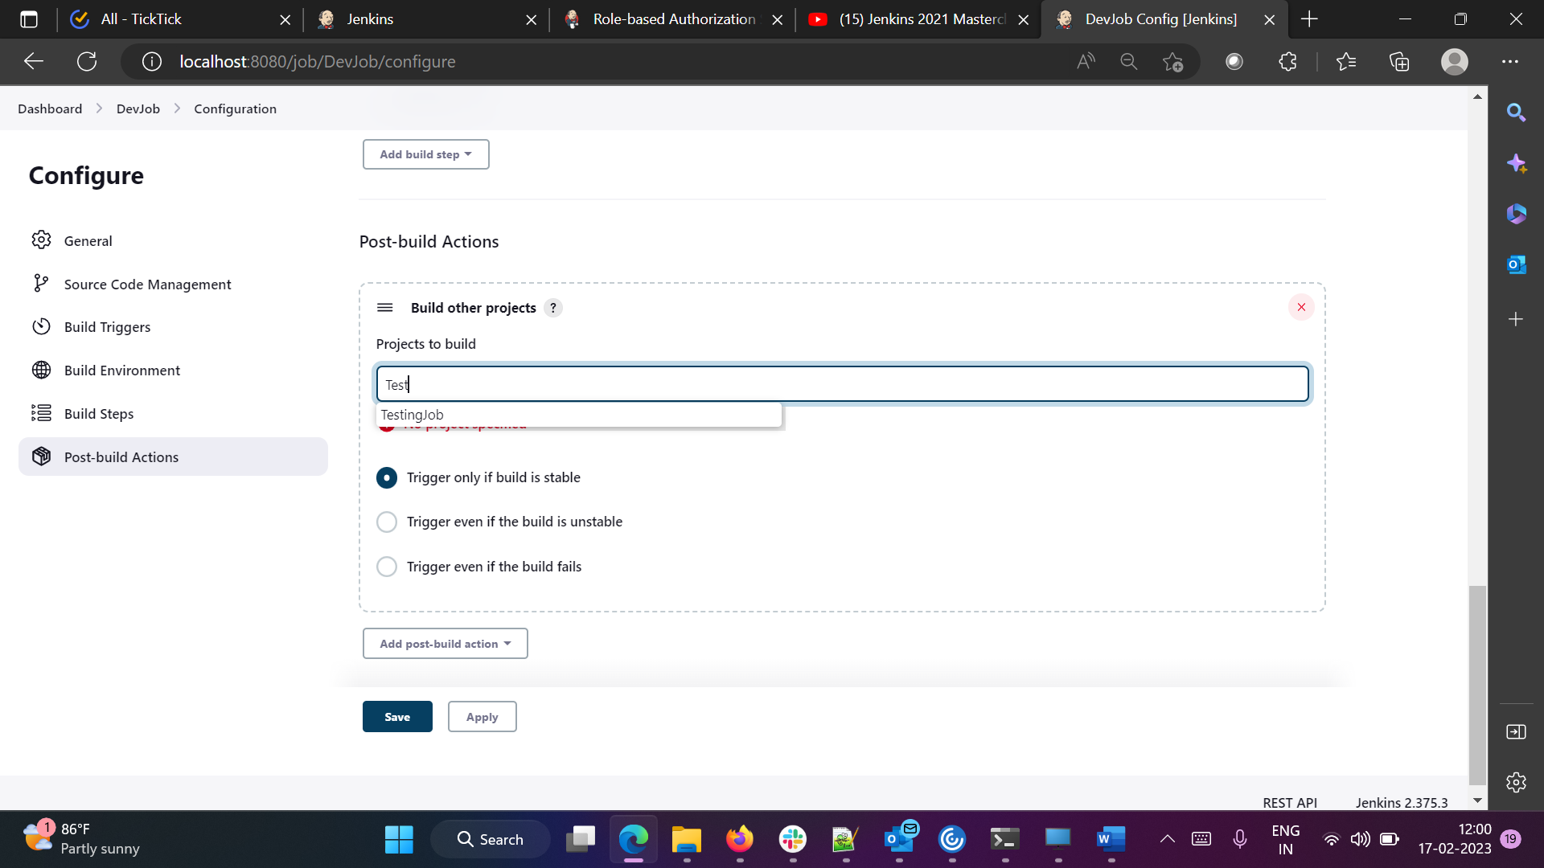

To verify this, if yu go to testing job you will see this.

1. **Build pipeline**

Go to Manage Plugins and download Build Pipeline plugin

Now go to homepage and click on (+) button

Select the initial job as devjob. SO when it starts first, next testing job runs.

Enter the below details and create the pipeline

The below shows how your pipeline looks.

Click on Run at the top. Now both gets run and shows in green

1. **Jenkins Pipeline**

Jenkins File – Pipeline as a code is Jenkins File. With this we can implement Jenkins Pipeline.

Make sure that the below plugin is already installed else install it.

Click on New Item -> Pipeline

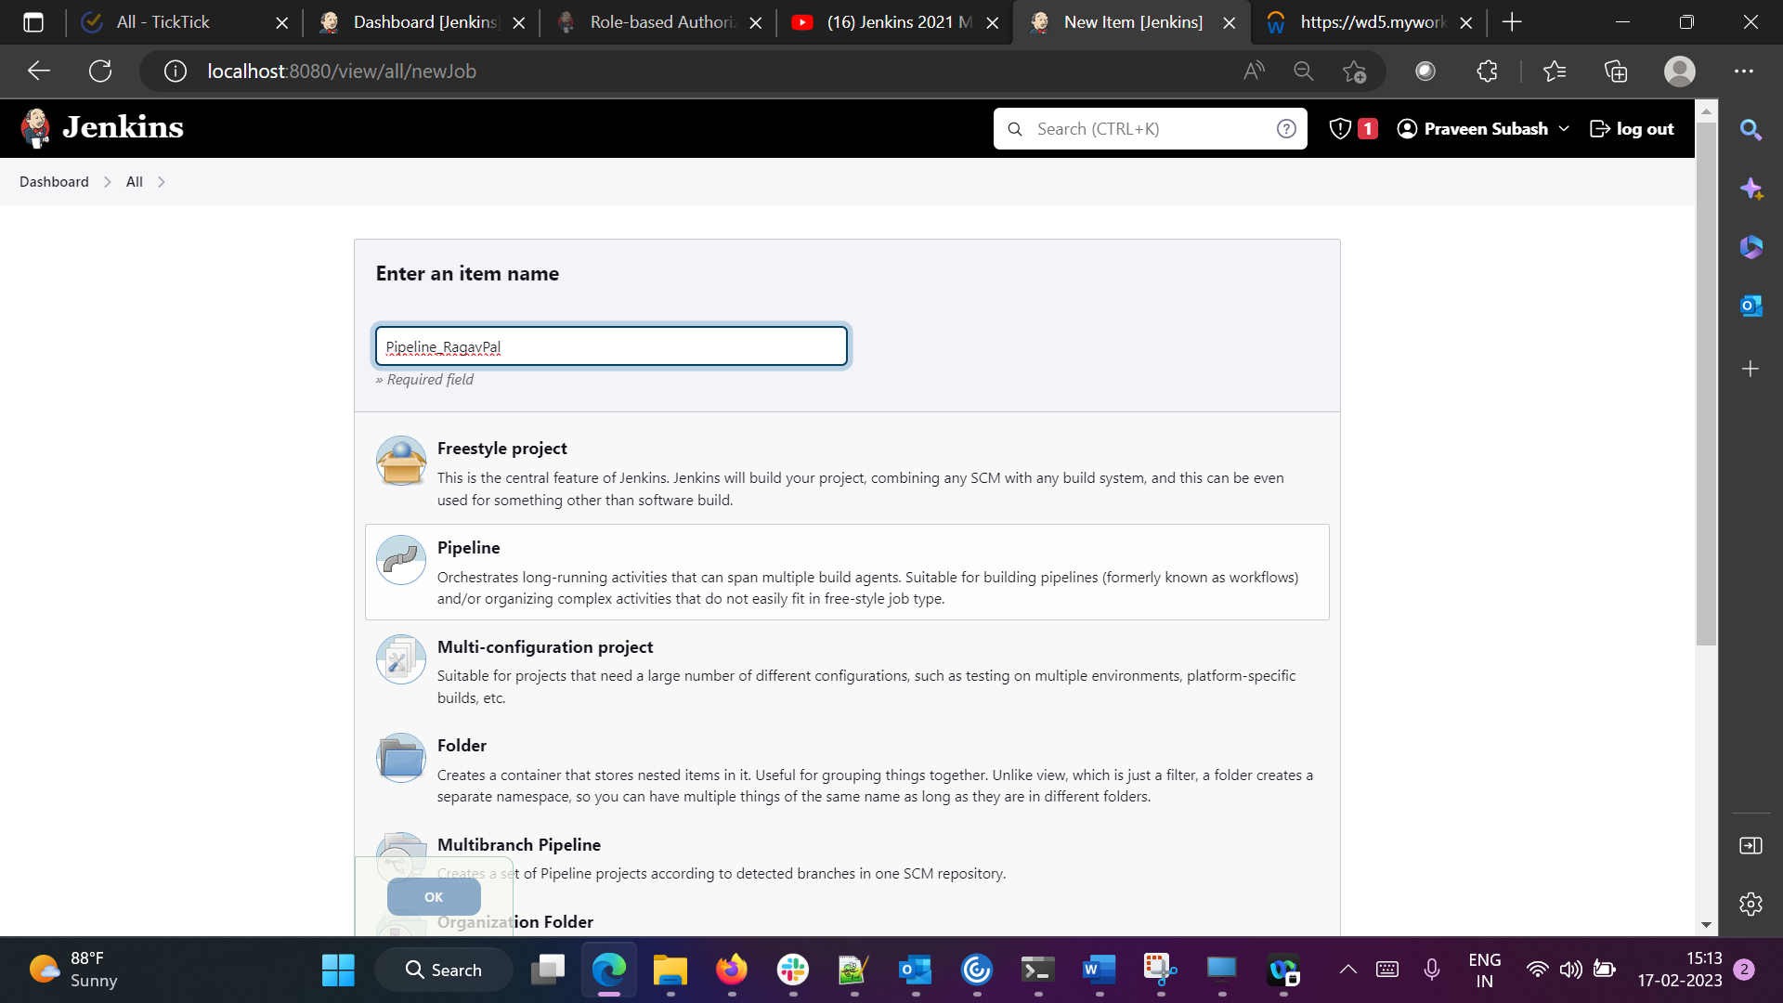

Here we can see 2 options. Either we can write our own Pipeline script or get it from Source Code Management like git.

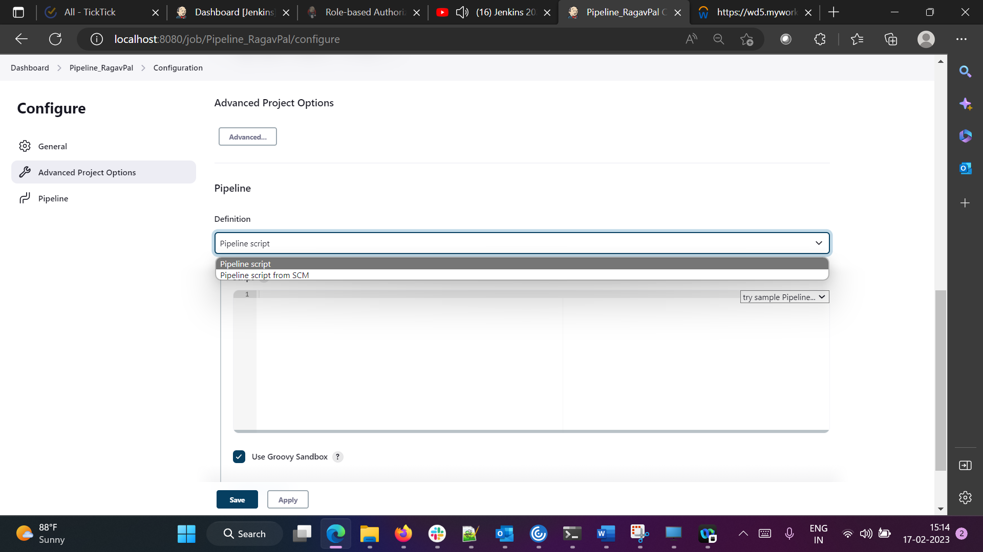

We can write our own pipeline script here and try the traditional scripted pipeline option. Below is the example

Our own pipleline script

Agent : we can use any specific agent. Here we use any

Stage : Build or deploy or dev or qa

Steps : what that pipeline should do

NOTE : If yu are not sure how to write a pipeline script, click on Pipeline Syntax

If you give the requirement, pipeline code gets generated

Now click on save. Pipleline home page gets generated

Now click on Build Now

Make changes like these and build

You can see different stages like below

1. **How to get Jenkins File from git SCM**

Step 1 : Create a pipeline. Under configuration you can see options like this

Choose pipeline script from SCM and select the options as below

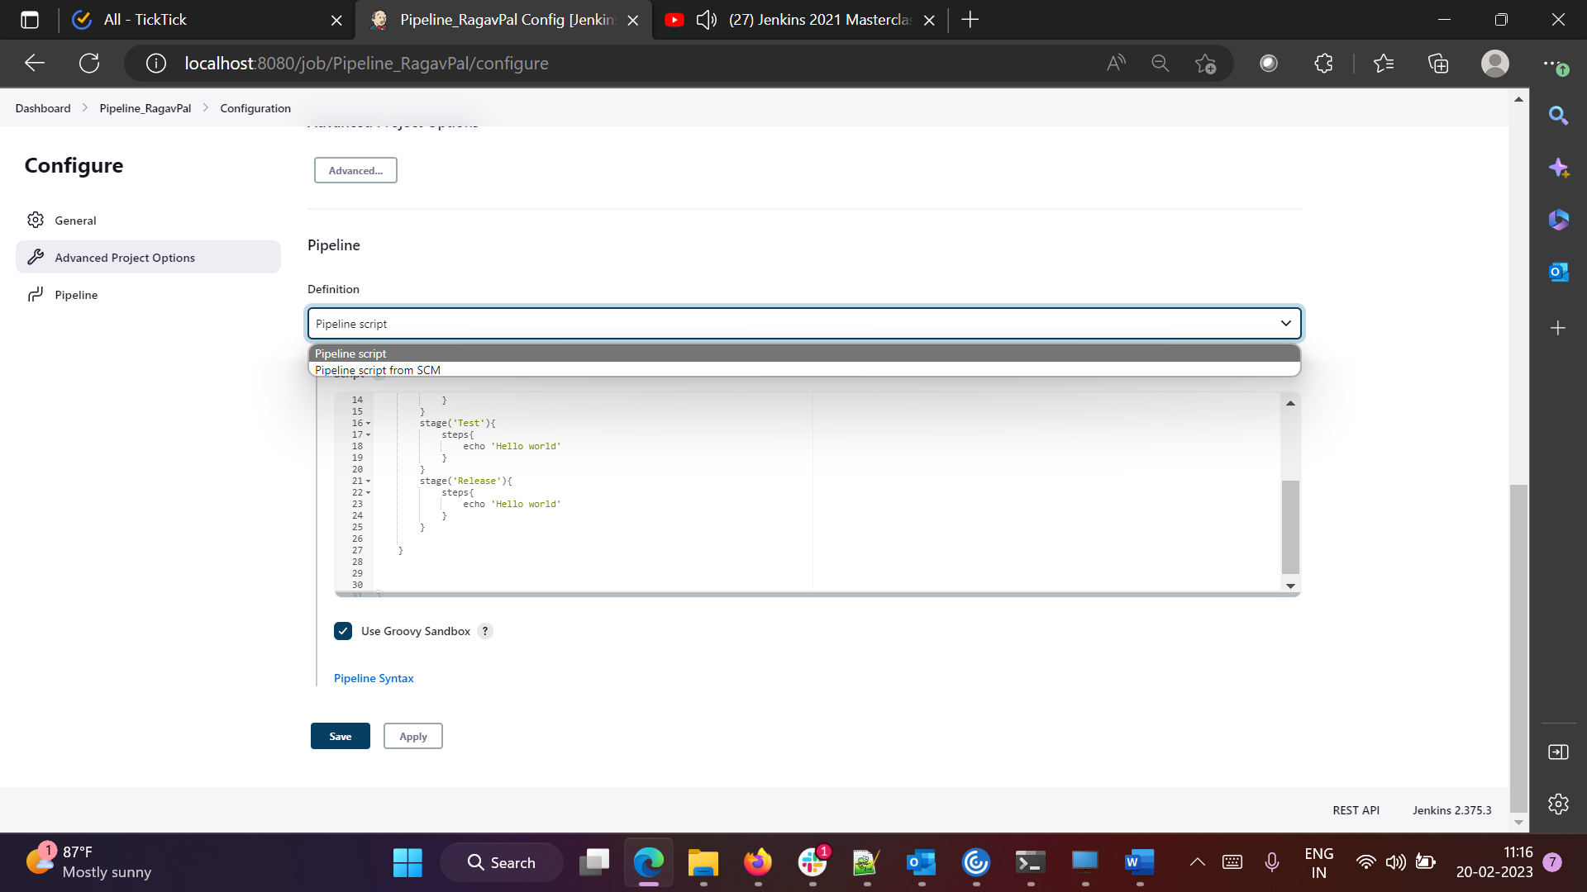

1. **How to clone a git repo using Jenkins File**

Take the pipeline and go to this link

Give the necessary details and get the jenkinsfile groovy script

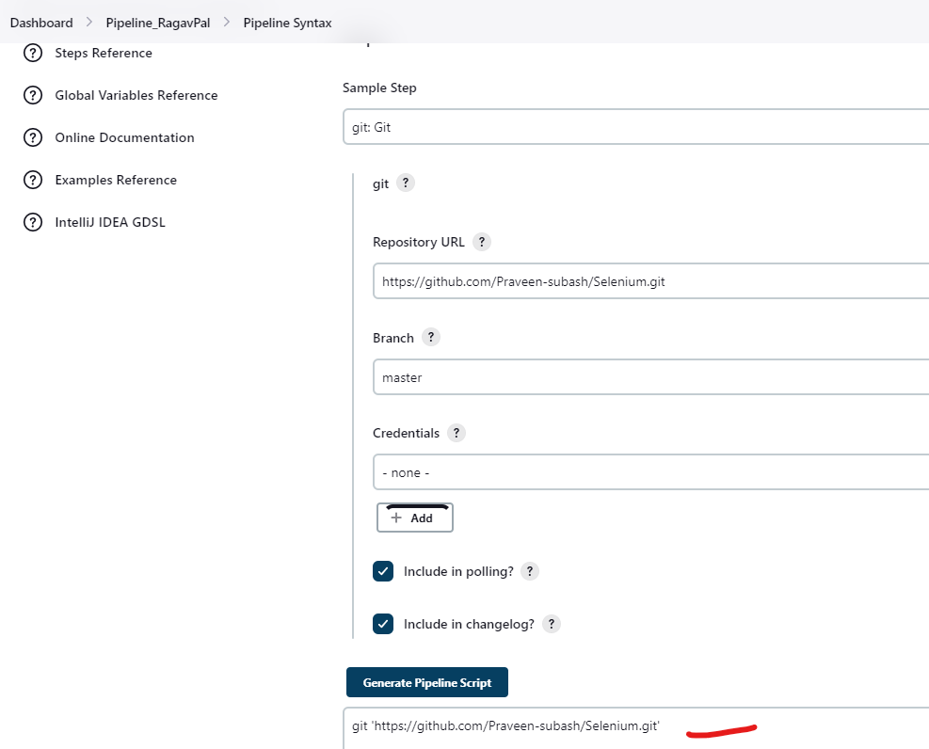

Now add it in the JenkinsFile and then build it

